## Cover Page

Project Title: Smart watch

Student Name(s): Eyal Loschitzky & Eilia Swed

**1. Project Topic and Description**

**General Background**

Falls and health-related incidents can occur unexpectedly in everyday settings. Affordable, embedded systems that continuously sense movement and basic physiological and environmental signals—while providing clear on-device feedback and a simple SOS channel—can improve safety and responsiveness. This project implements such a system on a low-cost microcontroller, combining motion analysis (for fall detection), basic vital/ambient monitoring, and a minimal user interface.

**Objectives**

* **Main Objective:**  
  Design and implement a real-time, multi-sensor monitoring system on the **NUC140** that detects falls, displays live readings, and can transmit alerts over Bluetooth.
* **Sub-objectives:**
  + Acquire analog signals from **heart-rate sensor** (ADC CH6), **temperature sensor** (ADC CH7), and **joystick** axes (ADC CH5/CH4).
  + Read 3-axis acceleration from **MPU6050** over **I²C** and perform a two-stage fall-detection algorithm (low-G → high-G).
  + Provide a simple UI on **LCD1602 (I²C)** with multiple screens: Home/Clock, Temperature, Heart BPM, Emergency, and Fall Alert.
  + Implement **Bluetooth (HC-05 over UART0 GPB0/GPB1)** to send SOS/alert messages.
  + Use a **timer interrupt (1 ms tick)** for timekeeping and stable loop timing; implement basic peak detection to convert raw heart signal to **BPM**.
  + Enable user navigation and time setting using the **joystick** (axes + button on **GPB9**).

**System Overview**

The NUC140 serves as the central controller. **Inputs** include the heart-rate sensor (ADC CH6), temperature sensor (ADC CH7), joystick X/Y (ADC CH5/CH4) and button (GPB9), plus the **MPU6050** accelerometer via **I²C (SCL P11, SDA P12)**. A 1 ms **Timer0** interrupt maintains a millisecond counter for timekeeping and UI pacing. The firmware filters/derives metrics (e.g., BPM via simple peak detection; fall events via magnitude thresholds and a two-phase state machine). **Outputs** are rendered on the **LCD1602 (I²C)** with dedicated screens, and critical events (SOS / fall detected) are transmitted over **Bluetooth HC-05 (UART0: RX=GPB0, TX=GPB1)**. Navigation between screens and clock setting are handled through the joystick, with debouncing and state control ensuring responsive, stable interaction.

**2. System Schematic and Connections**

**NUC140 System Connections Table**

|  |  |  |  |  |
| --- | --- | --- | --- | --- |
| **Component** | **Connection Type** | **NUC140 Pins / Interface** | **Power Supply** | **Notes** |
| **LCD1602 (I²C)** | I²C | • SCL → Pin 11  • SDA → Pin 12 | VCC = +5 V • GND | Shared I²C bus with MPU6050 |
| **MPU6050** | I²C | • SCL → Pin 11  • SDA → Pin 12 | VCC = 3.3 V • GND | ADDR/AD0 = Low → I²C address 0x68 |
| **HC-05** | UART0 | • TXD → NUC140 RX (GPB0 / Pin 32)  • RXD → NUC140 TX (GPB1 / Pin 33) | VCC = +5 V • GND | 9600 bps default |
| **Pulse Sensor** | ADC Input | Signal → ADC Channel 6 / Pin 77 | VCC = +5 V • GND | 12-bit ADC input |
| **TMP236** | ADC Input | Signal → ADC Channel 7 / Pin 78 | VCC = +5 V • GND | Analog temperature output |
| **Joystick Module** | ADC + GPIO | •VRx (X-axis) → ADC CH5 / Pin 76  • VRy (Y-axis) → ADC CH4 / Pin 75  • SW → GPB9 / Pin 50 (input) | VCC = +5 V • GND | Used for navigation and input |
| **Power & Ground** | – | +5 V and 3.3 V rails | – | Common ground for all devices |

**3. Code, Explanations, and Flowchart**

**1. System Initialization**

The program begins by unlocking the NUC140 system registers and setting the system clock.  
Afterward, several hardware modules are initialized in a strict order to ensure reliable operation of all sensors and communication peripherals.

**Initialization sequence:**

1. **UART0 Initialization (HC-05 Bluetooth module)**  
   Configured at 9600 baud, 8 data bits, no parity, 1 stop bit.  
   RX interrupt is enabled to receive incoming commands or emergency messages.
2. **Timer0 Initialization**  
   Configured as a **1 ms periodic timer interrupt**.  
   Each interrupt increments the global variable currentMillis, which acts as a time base for system delays and timing calculations.
3. **ADC Initialization**  
   The Analog-to-Digital Converter is configured for **single-end, single-cycle mode** to read multiple analog channels:
   * Channel 4 → Joystick Y
   * Channel 5 → Joystick X
   * Channel 6 → Heart sensor
   * Channel 7 → Temperature sensor
4. **GPIO Initialization**
   * GPB9 is configured as a **digital input** for the joystick button.
5. **I2C0 Initialization**  
   The I2C communication bus is enabled at **100 kHz**, with
   * SCL = Pin 11
   * SDA = Pin 12.
6. **LCD Initialization (LCM1602 via I2C)**  
   The LCD module is initialized through the I2C bus, cleared, and made ready for display.
7. **MPU6050 Initialization (Accelerometer)**  
   The accelerometer is awakened from sleep mode, set to a **±4 g range**, and configured for a **1 kHz sampling rate**.
8. **Variable Initialization**  
   Main runtime variables are set:
   * rState = 0 (initial mode)
   * time = 00:00:00
   * BPM = 80
   * count = 0, etc.

**2. Main Program Loop while (1)**

After initialization, the program enters the infinite loop that continuously monitors all sensors and updates the user interface.

**a. ADC Sampling**

Each cycle starts with ADC conversion:

* Vx, Vy (joystick axes)
* Heart (pulse sensor)
* Temp (temperature sensor)

The program waits until all conversions are complete before proceeding.

**b. Temperature Conversion**

The raw ADC value is converted into degrees Celsius using:

$$V_{in}=\frac{\text{ADC Value}×4.7}{4096} \\ T(°C)=(V_{in}-0.4)×51$$

This formula corresponds to a sensor with a 400 mV offset and ~19.6 mV/°C sensitivity.

**c. Heart Rate Calculation**

The function convert_raw_to_bpm() performs a **simple peak-detection** algorithm on the heart sensor’s signal:

* Detects rising peaks.
* Counts intervals between them.
* Converts to BPM using time differences based on currentMillis.

**d. Clock Update**

A software clock increments seconds, minutes, and hours approximately everyone second using the timer base

**3. Fall Detection (Two-Stage Algorithm)**

The function fall_chk() continuously reads acceleration data from the **MPU6050**:

* Detects **low-G (free-fall)** phase when acceleration < 0.3 g.
* Then looks for a **high-G (impact)** event (> 1.0 g).  
  If both conditions occur sequentially, a fall is confirmed.

When a fall is detected:

* The LCD displays **“Fall Detected!”**
* A warning message is transmitted via **UART Bluetooth**.
* The system delays ~1 second before returning to the home screen.

**4. Joystick Navigation & State Machine**

If no fall is detected, the program handles user input via the joystick:

* **Right movement (Vy > 3500)** → move to next screen (rState++)
* **Left movement (Vy < 1800)** → move to previous screen (rState--)
* **Centered position (2300–3000)** → reset debounce flag

This allows cyclic navigation between display modes.

**rState values:**

|  |  |  |
| --- | --- | --- |
| **State** | **Screen / Function** | **Description** |
| 0 | **Time Setup** | Adjust hour/minute using joystick X; press SW to confirm. |
| 1 | **Home Screen** | Displays real-time clock. |
| 2 | **Temperature** | Displays current temperature (°C). |
| 3 | **Heart Rate** | Displays measured BPM. |
| 4 | **Emergency Mode** | Press SW to send “please help” via UART. |
| 5 | **Fall Alert** | Triggered automatically by fall_chk(). |

**6. Summary**

This architecture ensures real-time monitoring of environmental and physiological parameters:

* **Heart rate** via analog peak detection
* **Temperature** via ADC conversion
* **Motion/fall detection** via accelerometer
* **User interface** through joystick and LCD
* **Emergency communication** via Bluetooth

All subsystems are synchronized using the **Timer0 interrupt** and managed by a simple **state-machine logic** to ensure smooth operation, quick response, and safe behavior in case of detected falls.

**7. code: added in the moddle**

**4. Results and System Images**

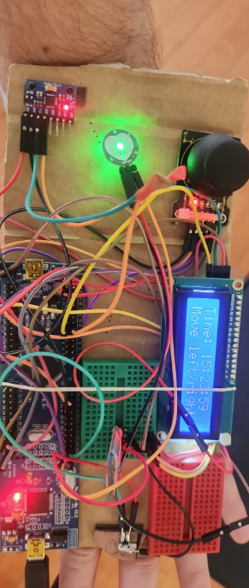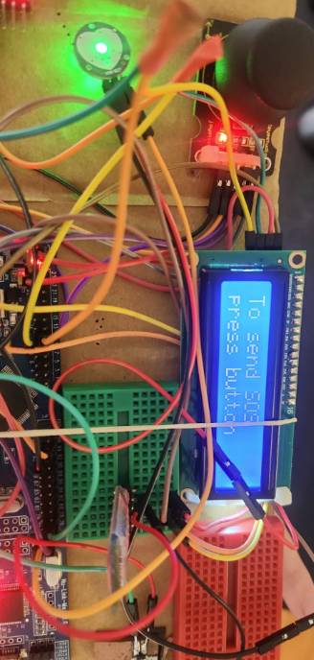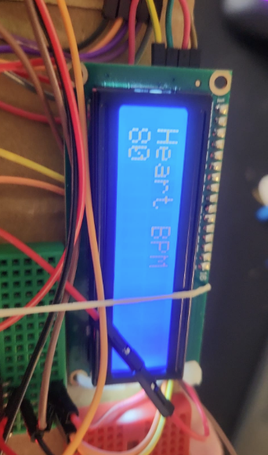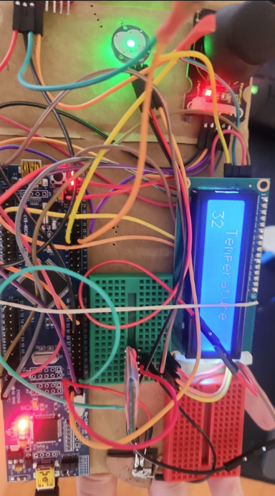

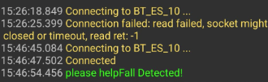

**5. Conclusion**

This project successfully demonstrated the design and implementation of an **embedded multi-sensor monitoring system** using the **NUC140 microcontroller**.  
The system integrated several modules — including **MPU6050 (accelerometer/gyroscope)**, **LCD1602 (I²C)**, **HC-05 Bluetooth**, **pulse sensor**, **temperature sensor**, and a **joystick** — to provide real-time monitoring and user interaction.

Through the developed firmware, the system was able to:

* Continuously measure **temperature**, **heart rate (BPM)**, and **motion acceleration**.
* Detect potential **falls** using a two-stage (low-G / high-G) detection algorithm.
* Display all readings and menus on the **LCD1602** screen, with joystick-based navigation.
* Transmit alert messages, including emergency or fall events, via **Bluetooth communication** to a remote computer.

**Challenges Faced**

During development, several difficulties were encountered:

* Calibrating the **MPU6050** sensor and tuning the fall-detection thresholds to minimize false triggers.
* Handling **signal noise** from the heart-rate sensor to achieve more stable BPM readings.
* Synchronizing multiple peripherals (I²C, UART, ADC, and timers) under real-time constraints.

**Future Improvements**

Possible future extensions and enhancements include:

* Adding **wireless data logging** or a **mobile app** for remote monitoring.
* Implementing **machine learning** for smarter fall classification and adaptive thresholding.
* Integrating additional sensors such as humidity or SpO₂ for broader health monitoring.
* Optimizing the **power consumption** and miniaturizing the hardware for wearable use.

Overall, the project achieved its objectives and provided a solid foundation for future development of real-time health and safety monitoring systems based on embedded microcontrollers.